深圳大学考试答题纸
(以论文、报告等形式考核专用)
二○一 九 ～二○二 ○ 学年度第 2 学期
课程编号 | 1502860001 |  | 课程名称 |  | 多媒体系统导论 |  | 主讲教师 |  | 王旭 | 评分
学 号 | 2018152083 |  | 姓名 | 李文婧 |  | 专业年级 |  | 计算机科学与技术大二
教师评语：
题目： |  | 基于内容的图像检索

【Title】Content based image retrieval system

【Abstract】
Image retrieval is an image and image retrieval service provided to users by retrieving image text or features. Content based image retrieval (CBIR) is to analyze and classify the input image, and to establish a unified model, extract its color, shape, texture, contour and spatial position features, establish a feature index and store it in the feature database. Content based image search (CBIR) is a mature technology, which is widely used in shopping software, search function, image recognition and motor. The research system performs similar image search based on the images provided by users to the system. During retrieval, the user displays the query source image and defines the query conditions through the user interface, which can be represented by one or more feature combinations: these features are quantified and stored in the mat file by analyzing the general color and texture characteristics. Then, the corresponding images are extracted from the image database, and the spatial shape and relation images are sorted according to the final results, and the three closest images are determined as the results, which are fed back to users in the order of similar size.
【Text】
The first chapter
introduces the content-based image retrieval and related work
1.1 Introduction
With the rapid development of Internet technology, a large number of data show exponential growth every day. How to process these images is a research hotspot in the field of multimedia information, and image retrieval is a very important link. Since the early research on image retrieval, it mainly uses text-based image retrieval (TBIR Gen). Each image has its own name. When searching, it needs to find the corresponding image by matching the name. This technology uses text description to describe the characteristics of the image, such as author, age, class, size, size, etc. In the 1990s, there are technologies to analyze and restore the semantic of image content, such as color, texture, configuration, etc., that is, content-based image retrieval technology. The disadvantage of this method is obvious: each photo has a lot of work to label, which cannot be processed when a large number of images are labeled. Then came a content-based image retrieval system (CBIR), which can describe the image features vector and store the image features - when the image is restored, the image features are extracted to obtain the query vector, and then find the most similar image features in the character library. Content based image search, such as search engines, purchasing software and recognition software, has also been applied.
1.2 Experiment related work
Firstly, the features of the image are selected as the basis for calculating the similarity between images, and then the index is established and the obtained features are written into the mat file. Then the obtained features are compared with the contents in the index.

The second chapter
analyzes the principle and method of content-based image retrieval
2.1 Color features
Color features are extracted by color moments. Color moment is a simple and effective color feature representation method. Its mathematical basis is that any color distribution in the image can be represented by its matrix. There are first-order moment (mean value), second-order moment (variance) and third-order moment (slope). The color information is mainly distributed in the low order moments. By using the first, second and third moments, the color distribution can be easily understood. The color moment of an image only needs 9 components (3 color components, 3 lower order moments on each component) to represent the color and distribution of the image.
2.2 Image texture
Image texture is to calculate the quantitative image characteristics of an image. The image structure describes the color space distribution and light intensity distribution of the image or its sub regions.
Texture feature extraction is divided into structural method and data-based method statistics. The methods of extracting texture features from the structure include simulating the texture to be detected and searching. The image method can obtain better results in the synthetic texture recognition. However, the method based on statistical data is more effective in recognizing the texture in business image.
LBP method is used to extract texture features. Its function is to extract features and extract local texture features. The original LBP algorithm is defined as: in a 3 × 3 window, the threshold value is the center pixel of the window, and the gray values of 8 adjacent pixels are compared. If the surrounding pixel value is greater than the center pixel value, the pixel's position is marked as 1, otherwise it is 0. The values of 8 * 8 points in this region can be used to reflect the values of 3 points in the region.
2.3 Shape features
When the feature is used for retrieval, users can find images similar to the shape from the image database by sketching the shape or outline of the image. There are two retrieval methods based on this feature: first, the contour of the target image is obtained after edge extraction of the segmented image, and the shape feature retrieval is carried out for this contour line. Secondly, the appropriate vector feature retrieval algorithm is found for graphics directly. The model-based method usually uses the geometric relationship of the object or the feature points of the object to estimate. The basic idea is to use a certain geometric model or structure to represent the structure and shape of an object, and to establish a corresponding relationship between the model and the image by extracting some object features, and then estimate the space pose of the object by geometry or other methods. The model used here may be simple geometry, such as plane and cylinder, or some geometry structure, or three-dimensional model obtained by laser scanning or other methods. However, it is more complex to deal with this kind of structured retrieval, and more preprocessing is needed.
2.4 Process implementation
- Firstly, input the data set and import the pictures in the selected data set into the program.
- The program establishes an index after processing all the images, extracts texture features and color moment features from these images, and stores them into the mat file for retrieval.
- Texture feature and color moment feature are both one-dimensional vector. Euclidean distance of color moment and texture feature vector in image to be retrieved and Ma file are calculated respectively, and different weights are given. These distances are sorted in ascending order to get the image retrieval results.
The specific implementation process is as follows：
(1) Data input:
Input the pictures in the data set into the program to standardize the naming form, number and size of the pictures.
(2) Feature extraction:
The effective information of the data is extracted by dimensionality reduction, and the image is transformed into vector representation.
(3) Similarity calculation:
The metric function is selected to calculate the distance between image features, which is used as the loss to train the feature extraction network, so that the features extracted from similar images are similar, and the features extracted from different types of images are quite different.
(4) Sort:
The similarity obtained in the third step is reordered according to the order of magnitude, so as to get better retrieval results.

Core code ：
%GETMAPPING返回一个包含LBP代码映射表的结构。
%MAPPING=GETMAPPING（SAMPLES，MAPPINGTYPE）返回一个
%结构包含的映射表
%样本抽样邻域中的LBP码
%积分。MAPPINGTYPE的可能值为
%“u2”表示统一LBP
%旋转不变LBP的“ri”
%“riu2”用于均匀旋转不变LBP。
%
%示例：
%I=imread（'大米.tif');
%MAPPING=获取映射（16，'riu2'）；
%LBPHIST=lbp（I，2,16，映射，'hist'）；
%现在LBPHIST包含一个旋转不变的统一LBP
%（16,2）邻域的直方图。 %
function mapping = getmapping(samples,mappingtype)
matlab_ver = ver('MATLAB');
matlab_ver = str2double(matlab_ver.Version);

if matlab_ver < 8
mapping = getmapping_ver7(samples,mappingtype);
else
mapping = getmapping_ver8(samples,mappingtype);
end

end

function mapping = getmapping_ver7(samples,mappingtype)

disp('For Matlab version 7.x and lower');

table = 0:2^samples-1;
newMax = 0; %结果LBP代码中的模式数
index = 0;

if strcmp(mappingtype,'u2') %Uniform 2
newMax = samples*(samples-1) + 3;
for i = 0:2^samples-1
j = bitset(bitshift(i,1,samples),1,bitget(i,samples)); %向左旋转
numt = sum(bitget(bitxor(i,j),1:samples)); %1->0和
%0->1转换
%在二进制字符串中
%x等于
%输入的1位数
%异或（x，向左旋转（x）） if numt <= 2
table(i+1) = index;
index = index + 1;
else
table(i+1) = newMax - 1;
end
end
end

if strcmp(mappingtype,'ri') 旋转不变量
tmpMap = zeros(2^samples,1) - 1;
for i = 0:2^samples-1
rm = i;
r = i;

for j = 1:samples-1
r = bitset(bitshift(r,1,samples),1,bitget(r,samples)); %旋转
%左 if r < rm
rm = r;
end
end
if tmpMap(rm+1) < 0
tmpMap(rm+1) = newMax;
newMax = newMax + 1;
end
table(i+1) = tmpMap(rm+1);
end
end

if strcmp(mappingtype,'riu2') %一致旋转不变
newMax = samples + 2;
for i = 0:2^samples - 1
j = bitset(bitshift(i,1,samples),1,bitget(i,samples)); %rotate left
numt = sum(bitget(bitxor(i,j),1:samples));
if numt <= 2
table(i+1) = sum(bitget(i,1:samples));
else
table(i+1) = samples+1;
end
end
end

mapping.table=table;
mapping.samples=samples;
mapping.num=newMax;
end

function mapping = getmapping_ver8(samples,mappingtype)

disp('For Matlab version 8.0 and higher');

table = 0:2^samples-1;
newMax = 0; %结果LBP代码中的模式数
index = 0;

if strcmp(mappingtype,'u2') %Uniform 2
newMax = samples*(samples-1) + 3;
for i = 0:2^samples-1

i_bin = dec2bin(i,samples);
j_bin = circshift(i_bin',-1)'; %向左循环旋转
numt = sum(i_bin~=j_bin); %个数1->0和
%0->1转换
%在二进制字符串中
%x等于
%输入的1位数
%异或（x，向左旋转（x））
if numt <= 2
table(i+1) = index;
index = index + 1;
else
table(i+1) = newMax - 1;
end
end
end

if strcmp(mappingtype,'ri') %Rotation invariant
tmpMap = zeros(2^samples,1) - 1;
for i = 0:2^samples-1
rm = i;

r_bin = dec2bin(i,samples);

for j = 1:samples-1

r = bin2dec(circshift(r_bin',-1*j)'); %rotate left
if r < rm
rm = r;
end
end
if tmpMap(rm+1) < 0
tmpMap(rm+1) = newMax;
newMax = newMax + 1;
end
table(i+1) = tmpMap(rm+1);
end
end

if strcmp(mappingtype,'riu2') %Uniform & Rotation invariant
newMax = samples + 2;
for i = 0:2^samples - 1

i_bin = dec2bin(i,samples);
j_bin = circshift(i_bin',-1)';
numt = sum(i_bin~=j_bin);

if numt <= 2
table(i+1) = sum(bitget(i,1:samples));
else
table(i+1) = samples+1;
end
end
end

mapping.table=table;
mapping.samples=samples;
mapping.num=newMax;
end

The third chapter
experimental demonstration
3.1 Mean Average Precision（mAP）
Map is to solve the single point value limitation of precision, recall and F-measure. In order to get an index which can reflect the global performance.
This is the most commonly used performance index to evaluate the information retrieval system, the average accuracy rate (map), which is defined as follows: (where p, R are accuracy rate and recall rate respectively)
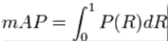
Map (mean average precision): the average precision of a single topic is the average of the precision of each related document after retrieval.
The mean precision mean (map) of the main set is the average of the average accuracy of each topic.
Map is a single value index reflecting the performance of the system on all relevant documents.
The higher the rank, the higher the map may be. If the system does not return relevant documents, the accuracy rate is 0 by default.
This program selects Oxford 5K and paris6k data sets to test. The results are as follows：
 | Oxford5k | Paris6k
mAP | 0.693 | 0.662

3.2 examples of running results
Considering the efficiency of the program, only 100 images are placed in the image folder for testing. The following figure shows the results of the program. The first image is the image we input for retrieval, and the second to fourth image retrieval results are the image retrieval results, that is, the three images most similar to the input image are retrieved.
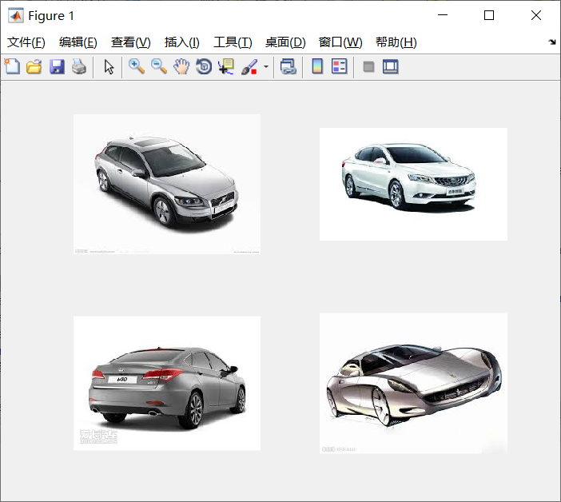
Example 1
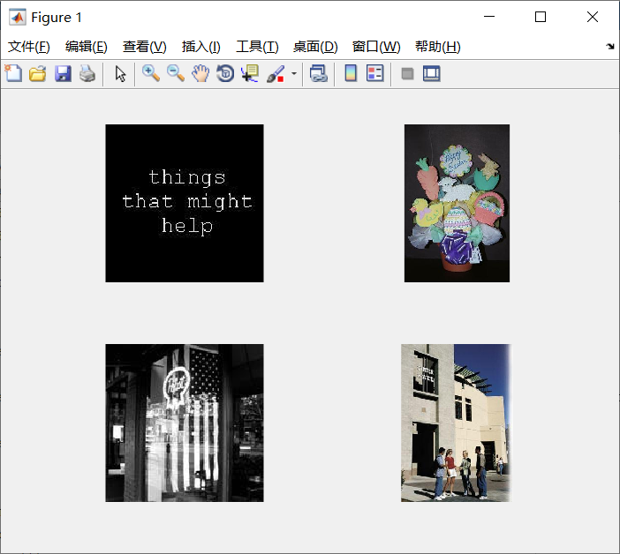
Example 2
【conclusion】
Image restoration technology based on deep learning mainly applies deep learning method to feature extraction module in image restoration. The main step of extracting image features by neural network is to provide images and extract image features with convex neural network. By measuring Euclidean distance and other learning methods to calculate the distance of image features, get the preliminary results, adjust the size of image retrieval results according to the context information and data flow structure, improve the accuracy of image retrieval, and get the final retrieval results.

【reference】
- 网页https://www.sohu.com/a/288789796_468740
- 网页https://blog.csdn.net/yuanhuiling/article/details/79113962
- 周明全, 耿国华, 韦娜. 基于内容图像检索技术[M]. 清华大学出版社, 2007.
- 黄祥林, 沈兰荪. 基于内容的图像检索技术研究[J]. 电子学报, 2002, 30(7):1065-1071.
- 赵珊. 基于内容的图像检索关键技术研究[D]. 西安电子科技大学, 2007.

